 **MINISTRY OF EDUCATION AND TRAINING**

**FPT UNIVERSITY**

Capstone Project Document

**Timetable Management Support Tools**

|  |  |
| --- | --- |
| **Group 6** | |
| **Group member** | Lu Quoc Cuong - SE60940  Pham Tran Tuan Vu - SE61063  Ho Thien Nguyen - SE60850  Ha Trong Trung – SE60597 |
| **Supervisor** | Mr. Kieu Trong Khanh |
| **Ext. Supervisor** | N/A |
| **Capstone Project code** | TMST |

-Ho Chi Minh City, 05/01/2015-

# Table of Contents

Table of Contents 3

List of Tables 4

List of Figures 5

Definitions, Acronyms, and Abbreviations 6

E. System Implementation & Test 7

1. Introduction 7

1.1 Overview 7

1.2 Test Approach 7

2. Database Relationship Diagram 7

2.1 Physical Diagram 7

2.2 Data Dictionary 8

3. Performance Measures 16

3.1 Send Mail Performance 16

3.2 Synchronize Performance 16

3.3 Suggestion Algorithm Performance 16

4. Test Plan 16

4.1 Features to be tested 16

4.2 Features not to be tested 17

5. System Testing Test Case 17

5.1 Core Flow 1 19

5.2 Core Flow 2 28

# List of Tables

Table 1: Data Dictionary 10

Table 2: Attribute Data Dictionary 16

Table 3: Import Plan Semester. 19

Table 4: Import Classes List 20

Table 5: Suggest Temporary Timetable 21

Table 6: View Temporary Timetable 21

Table 7: Edit Temporary Timetable 22

Table 8: Export Temporary Timetable 22

Table 9: Import Instructor List 23

Table 10: Check Conflict Temporary Timetable 24

Table 11: Suggest Complete Timetable. 25

Table 12: View Complete Timetable 25

Table 13: Edit Complete Timetable 27

Table 14: Check Conflict Complete Timetable 27

Table 15: Import Project Group List 30

Table 16: Suggest Guide Project Schedule 33

Table 17: View Guide Project Schedule 34

Table 18: Edit Guide Project Schedule 36

Table 19: View Room Usage Schedule 36

Table 20: Suggest Room Usage Schedule 36

Table 21: Edit Room Usage Schedule 37

Table 22: Calculate and View Timekeeping 37

# List of Figures

Figure 1: Database Relationship Diagram 8

Figure 2: Core Flow 1 18

Figure 3: Core Flow 2 18

# Definitions, Acronyms, and Abbreviations

|  |  |
| --- | --- |
| **Name** | **Definition** |
| TMST | Timetable Management Support Tools |
| PK | Primary Key |
| FK | Foreign Key |

# System Implementation & Test

## Introduction

### Overview

This section provides in detail all necessary information about test plans, test cases, test result, test environments, pass/fail criteria and risks estimations as well as a checklist to cover all possible cases of this project.

### Test Approach

* Goal: To test the whole system based on the core workflow.
* Method: System Testing, Black – box Testing.

## Database Relationship Diagram

### Physical Diagram

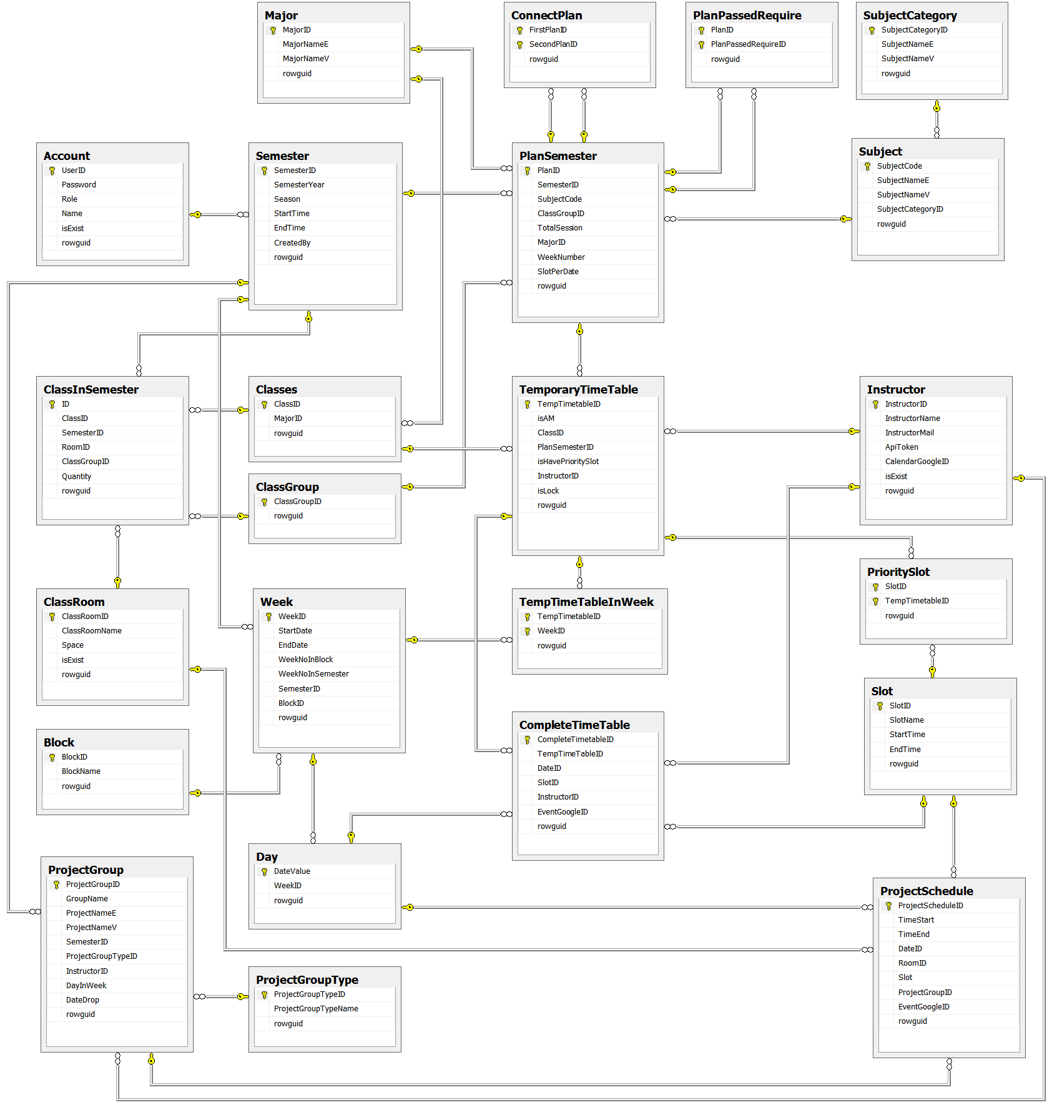

Figure : Database Relationship Diagram

### Data Dictionary

#### Data Dictionary

|  |  |
| --- | --- |
| **Entity Name** | **Description** |
| Account | Describe all users of the system. Each user has only one account. |
| Semester | Describe the semester of FPT University, each semester in FPT University is about 4 months. |
| ClassRoom | Describe the room of FPT University which can be used for teaching. |
| Class | Describe the class in FPT University. Each class is a set of students who have same courses. |
| ClassInSemester | Describe a specific class in a specific semester. |
| ClassGroup | Describe a set of classes in FPT University have the same plan in a semester. |
| Major | Describe a set of classes in FPT University have the same major. |
| Slot | Describe a slot in FPT University. Each slot is 90 minutes. |
| Day | Describe the official day in FPT University’s curriculum. Each day has 8 slots. |
| Week | Describe the week in FPT University’s curriculum. |
| Block | Describe the sets of weeks defined by FPT University. |
| Subject | Describe all available subject in FPT University. |
| SubjectCategory | Describe a set of Subjects. |
| PlanSemester | Describe specific subjects which are available for each class group in a specific semester. Each semester has many plan semesters. |
| PlanPassedRequire | Describe a PlanSemester have to be learned before one or other PlanSemesters. |
| ConnectPlan | Describe a PlanSemester have to be learned right after another PlanSemester (both of them have to learn in the same Semester). |
| Instructor | Describe all instructors in FPT University. |
| CompleteTimetable | Describe the timetable in FPT University. Each timetable is about a set of answers for these questions: which class has which subjects, teaching by who (instructor), at which specific period? |
| TemporaryTimetable | Describe the timetable in a brief description way. |
| TempTimeTableInWeek | Describe which weeks the Temporary Timetable is assigned in. |
| PrioritySlot | Describe which slots the Temporary Timetable is assigned at. |
| ProjectGroup | Describe a set of students who is doing Capstone Project and Graduation Thesis. |
| ProjectGroupType | Describe the type of project group. |
| ProjectSchedule | Describe the time for meeting of project groups with their Instructor. |

Table : Data Dictionary

#### Attribute Data Dictionary

|  |  |  |  |  |
| --- | --- | --- | --- | --- |
| **Table name** | **Attributes** | **Description** | **Domain** | **Null** |
| Account | UserID {PK} | Account username | varchar(50) | No |
| Password | Account password | varchar(50) | No |
| Role | Unique identifier of a role (1: Admin, 2: Staff) | int | No |
| Name | Account username | nvarchar(50) | No |
| isExist | Account status | bit | No |
| rowguid | Row ID, this attribute uses for synchronizing data between local and server | uniqueidentifier | No |
| Semester | SemesterID {PK} | Unique identifier of a semester, auto increment | int | No |
| SemesterYear | Semester Year | int | No |
| SemesterSeason | Semester Season (Spring, Summer, Fall) | varchar(30) | No |
| StartTime | The start date of semester | date | No |
| EndTime | The end date of semester | date | No |
| CreatedBy {FK} | Identity who creates a semester | varchar(50) |  |
| rowguid | Row ID, this attribute uses for synchronizing data between local and server | uniqueidentifier | No |
| SubjectCategory | CategoryID {PK} | Unique identifier of a subject category | varchar(10) | No |
| CategoryNameE | Subject category in English | varchar(50) | No |
| CategoryNameV | Subject category in Vietnamese | nvarchar(50) | No |
| rowguid | Row ID, this attribute uses for synchronizing data between local and server | uniqueidentifier | No |
| Subject | SubjectCode {PK} | Unique identifier of a subject | varchar(50) | No |
| SubjectNameE | Subject Name in Vietnamese | varchar(100) | No |
| SubjectNameV | Subject Name in Vietnamese | nvarchar(100) | No |
| SubjectCategoryID {FK} | Category of subject. | varchar(10) |  |
| rowguid | Row ID, this attribute uses for synchronizing data between local and server | uniqueidentifier | No |
| PlanSemester | PlanID {PK} | Unique identifier of a plan, auto  increment | int | No |
| TotalSession | Total session of a plan | int | No |
| WeekNumber | Week number of plan in semester | int | No |
| SlotPerDate | Number of slot per date of plan | int | No |
| SubjectCode {FK} | Identity a plan study what subject | varchar(50) | No |
| SemesterID {FK} | Identity a plan belong what semester | int | No |
| ClassGroupID {FK} | Identity a plan belong belong what class group | varchar(20) | No |
| MajorID {FK} | Identity a plan belong belong what major | nvarchar(10) | No |
| rowguid | Row ID, this attribute uses for synchronizing data between local and server | uniqueidentifier | No |
| PlanPassedRequire | PlanID {PK} | Identity what plan have to be learned before other plan. | int | No |
| PlanPassedRequireID {PK} | Identity what plan have to be learned after other plan. | int | No |
| rowguid | Row ID, this attribute uses for synchronizing data between local and server | int | No |
| ConnectPlan | FirstPlanID {PK} | Identity what plan have to be learned right before other plan. | int | No |
| SecondPlanID {PK} | Identity what plan have to be learned right after other plan. | int | No |
| rowguid | Row ID, this attribute uses for synchronizing data between local and server | int | No |
| Major | MajorID {PK} | Unique identifier of a major, auto increment | nvarchar(10) | No |
| MajorNameE | Major in English | varchar(100) | No |
| MajorNameV | Major in Vietnamese | nvarchar(100) | No |
| rowguid | Row ID, this attribute uses for synchronizing data between local and server | uniqueidentifier | No |
| ClassGroup | ClassGroupID {PK} | Unique identifier of a class group | varchar(20) | No |
| rowguid | Row ID, this attribute uses for synchronizing data between local and server | uniqueidentifier | No |
| Class | ClassID {PK} | Name of class, unique identifier | varchar(10) | No |
| MajorID {FK} | Identity a class belong what major | nvarchar(10) |  |
| rowguid | Row ID, this attribute uses for synchronizing data between local and server | uniqueidentifier | No |
| ClassInSemester | ID {PK} | Unique identifier, auto  increment | int | No |
| Quantity | Number of student of class in a semester | int | No |
| ClassID {FK} | Identity a class | varchar(10) | No |
| SemesterID {FK} | Identity a semester | int | No |
| RoomID {FK} | Identity a class study at what room in semester | int | Yes |
| ClassGroupID {FK} | Identity a class belong what class group in semester | varchar(20) | No |
| rowguid | Row ID, this attribute uses for synchronizing data between local and server | uniqueidentifier | No |
| ClassRoom | ClassRoomID {PK} | Unique identifier of a classroom, auto  increment | int | No |
| ClassRoomName | Name of classroom | nvarchar(30) | No |
| Space | Room space | int | No |
| IsExist | Classroom status | bit | No |
| rowguid | Row ID, this attribute uses for synchronizing data between local and server | uniqueidentifier | No |
| TemporaryTimeTable | TempTimetableID {PK} | Unique identifier of a course, auto increment | int | No |
| isAM | Identity the course study in AM or PM | bit | No |
| isHavePrioritySlot | Identity if the course have priority slot | bit | No |
| ClassID {FK} | Identity what class study a course | varchar(10) | No |
| PlanSemesterID {FK} | Identity what subject study a course | int | No |
| InstructorID {FK} | Identity who teach a course | varchar(30) | Yes |
| isLock | Identity if the course is locked | bit | No |
| rowguid | Row ID, this attribute uses for synchronizing data between local and server | uniqueidentifier | No |
| TempTimeTableInWeek | TempTimetableID {PK} | Identity what Temporary Timetable | int | No |
| WeekID {PK} | Identity what week of a temptimetable | int | No |
| rowguid | Row ID, this attribute uses for synchronizing data between local and server | int | No |
| PrioritySlot | TempTimetableID {PK} | Identity what Temporary Timetable | int | No |
| SlotID {PK} | Identity what slot | int | No |
| rowguid | Row ID, this attribute uses for synchronizing data between local and server | uniqueidentifier | No |
| Slot | SlotID {PK} | Unique identifier of a slot | int | No |
| SlotName | Slot name | varchar(10) | No |
| StartTime | Start time of a slot | time(7) | No |
| EndTime | End time of a slot | time(7) | No |
| rowguid | Row ID, this attribute uses for synchronizing data between local and server | uniqueidentifier | No |
| Instructor | InstuctorID {PK} | Unique identifier of an instructor | varchar(30) | No |
| InstructorName | Name of instructor | nvarchar(50) | No |
| InstructorMail | Mail of instructor | varchar(100) | No |
| CalenderGoogleID | Calendar ID in Google calendar | varchar(100) | Yes |
| ApiToken | Access token to synchronize Google calendar | varchar(100) | Yes |
| isExist | Instructor status | bit | No |
| rowguid | Row ID, this attribute uses for synchronizing data between local and server | uniqueidentifier | No |
| Block | BlockID {PK} | Unique identifier of a block | int | No |
| BlockName | Block name | varchar(10) | No |
| rowguid | Row ID, this attribute uses for synchronizing data between local and server | uniqueidentifier | No |
| Week | WeekID {PK} | Unique identifier of a week, auto  increment | int | No |
| StartDay | The start date of a week | date | No |
| EndDay | The end date of a week | date | No |
| WeekNoInBlock | Ordinal numbers of week in a block | int | No |
| WeekNoInSemester | Ordinal numbers of week in the semester | int | No |
| BlockID {FK} | Identity a week belong what block | Int | No |
| SemesterID {FK} | Identity a week belong what semester | int | No |
| rowguid | Row ID, this attribute uses for synchronizing data between local and server | uniqueidentifier | No |
| Day | DayValue {PK} | Unique identifier of a date | date | No |
| WeekID {FK} | Identity this date belong what week | int |  |
| rowguid | Row ID, this attribute uses for synchronizing data between local and server | uniqueidentifier | No |
| CompleteTimeTable | CompleteTimetableID {PK} | Unique identifier of a complete timetable, auto  increment | int | No |
| EventGoogleID | The Google event ID in Google calendar | varchar(100) | Yes |
| TempTimeTableID {FK} | Identity the course of a lesson | int | No |
| DateID {FK} | Identity date of a lesson | date | No |
| SlotID {FK} | Identity slot of a lesson | Int | No |
| InstructorID {FK} | Identity instructor of a lesson | varchar(30) | Yes |
| rowguid | Row ID, this attribute uses for synchronizing data between local and server | uniqueidentifier | No |
| ProjectGroupType | GroupTypeID {PK} | Unique identifier of a project group type | varchar(5) | No |
| GroupTypeName | Group type name | varchar(30) | No |
| rowguid | Row ID, this attribute uses for synchronizing data between local and server | uniqueidentifier | No |
| ProjectGroup | ProjectGroupID {PK} | Unique identifier of a group, auto  increment | int | No |
| GroupName | Name of group | nvarchar(30) | No |
| ProjectNameE | Project topic in English | varchar(200) | No |
| ProjectNameV | Project topic in Vietnamese | nvarchar(200) | No |
| DayInWeek | Number of date per week which instructor has meeting with students | int | No |
| DateDrop | The drop date of the group | date | Yes |
| SemesterID {FK} | Identity a group belong what semester | int | No |
| ProjectGroupTypeID {FK} | Identity a group belong what type | varchar(5) | No |
| InstructorID {FK} | Identity a group be guided by who | varchar(30) | No |
| rowguid | Row ID, this attribute uses for synchronizing data between local and server | uniqueidentifier | No |
| ProjectSchedule | ProjectScheduleID {PK} | Unique identifier of a projects schedule, auto  increment | int | No |
| ProjectGroupID {FK} | Identity what group have meeting | int | No |
| RoomID {FK} | Identity meeting at what room | int | No |
| Slot {FK} | Identity meeting in what slot | int | No |
| DateID {FK} | Identity a date of meeting | date | No |
| TimeStart | The start time of meeting | time(7) | No |
| TimeEnd | The end time of meeting | time(7) | No |
| EventGoogleID | The Google event ID in Google calendar | varchar(100) | Yes |
| rowguid | Row ID, this attribute uses for synchronizing data between local and server | uniqueidentifier | No |

Table : Attribute Data Dictionary

## Performance Measures

### Send Mail Performance

The total time for creating and sending mail for each instructor to SMTP host is less than 7 seconds per mail.

### Synchronize Performance

The speed of synchronize timetable and project guide schedule to Instructor’s Google Calendar is less than 2 seconds per record.

### Suggestion Algorithm Performance

* The speed of suggest temporary timetable is less than 1 second per class.
* The speed of suggest completed timetable is less than 0.2 second per class.

## Test Plan

The purpose of this section is to verify and ensure that TMST meets its design specification and other requirements from user. The following part will describe which features to be tested and which will not.

### Features to be tested

We will test the entire system based on the following core workflow (Reference: Figure 2, 3: Core Workflow).

Based on the workflow, all following features will be tested, which can include one or more functions. These features will be focused and tested thoroughly during the test phase.

Staff:

* Import Plan Semester.
* Import Classes List.
* View Temporary Timetable.
* Edit Temporary Timetable.
* Check Conflict Temporary Timetable.
* Export Temporary Timetable.
* Import Instructor List.
* View Complete Timetable.
* Edit Complete Timetable.
* Check Conflict Complete Timetable.
* Import Project Group List.
* Edit Guide Project Schedule.
* View Guide Project Schedule
* View Timekeeping
* View Room Usage Schedule
* Suggest Room Usage Schedule
* Edit Room Usage Schedule

System:

* Suggest Temporary Timetable.
* Suggest Complete Timetable.
* Suggest Room Usage.
* Suggest Guide Project Schedule.
* Calculate Timekeeping.

### Features not to be tested

* Login, Logout.
* Create New Semester.
* Open Semester.
* Manage Plan Semester.
* Manage Subject.
* Manage Class.
* Export Complete Timetable.
* Export Room Usage Schedule.
* Manage Group.
* Manage Instructor.
* Send Mail.
* Email Configure
* Synchronize Configure.

## System Testing Test Case

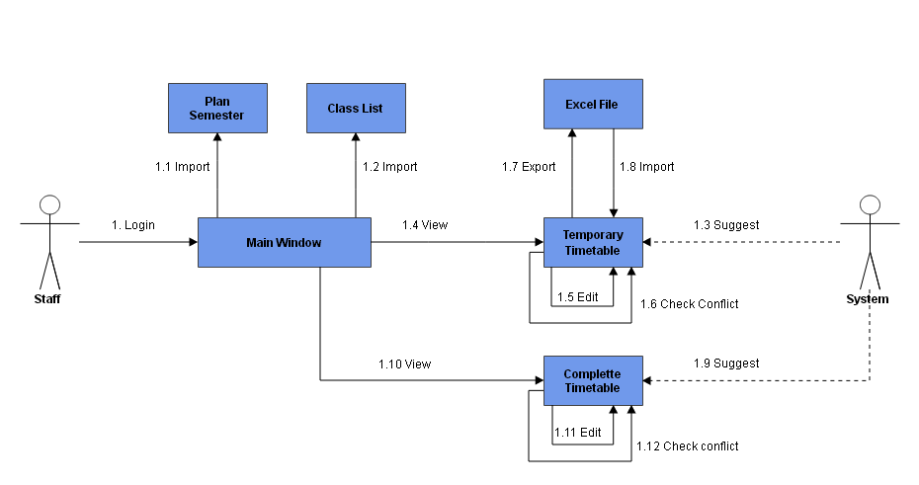

Figure : Core Flow 1

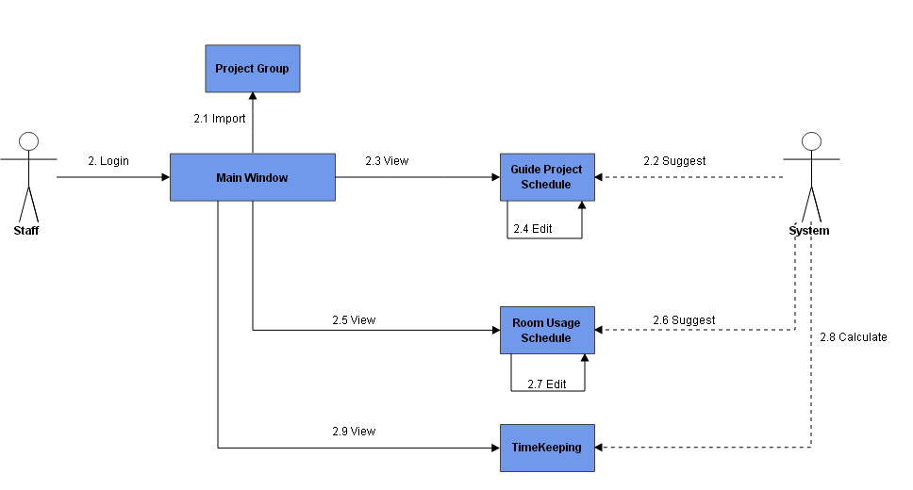

Figure : Core Flow 2

### Core Flow 1

#### Import Plan Semester.

|  |  |  |  |  |  |  |  |
| --- | --- | --- | --- | --- | --- | --- | --- |
| **ID** | **Test Case Description** | **Test Case Procedure** | **Expected output** | **Inter-test Case Dependence** | **Result** | **Test Date** | **Note** |
| PS01 | Input wrong excel file | 1-On file choose, select non excel file | -Show error message” Invalid extension file. |  | Passed | 17/04/2015 |  |
| PS02 | Not selected before save | 1-Check un to unselect all data  2-Click “Save” button | -Show warning error message “No subject is selected” |  | Passed | 17/04/2015 |  |
| PS03 | Exist error before save | 1-Data exist error, click save | -Show error message “There’s exist error, please check again” |  | Passed |  |  |
| PS04 | Edit Data: null data | 1-Double clicks on a row  2-Delete all data  3-Click “Update” button | -Show error message | PS01 | Passed | 17/04/2015 |  |
| PS05 | Edit Data: wrong data | -Double clicks on a row  2- Input wrong data  3-Click “Update” button | -Show error message | PS01 | Passed | 17/04/2015 |  |
| PS06 | Edit Data: right data | -Double clicks on a row  2- Input right data  3-Click “Update” button | -Close window  -Data updated | PS01 | Passed | 17/04/2015 |  |

Table : Import Plan Semester.

#### Import Classes List.

|  |  |  |  |  |  |  |  |
| --- | --- | --- | --- | --- | --- | --- | --- |
| **ID** | **Test Case Description** | **Test Case Procedure** | **Expected output** | **Inter-test Case Dependence** | **Result** | **Test Date** | **Note** |
| CL01 | Input wrong excel file | 1 - On file choose, select non excel file | - Show error message” Invalid extension file. |  | Passed | 17/04/2015 |  |
| CL02 | Not selected before save | 1 - Check un to unselect all data  2 - Click “Save” button | -Show warning error message “No subject is selected” |  | Passed | 17/04/2015 |  |
| CL03 | Exist error before save | 1 - Data exist error, click save | -Show error message “There’s exist error, please check again” |  | Passed |  |  |
| CL04 | Edit Data: null data | 1 - Double clicks on a row  2 - Delete all data  3 - Click “Update” button | -Show error message | CL01 | Passed | 17/04/2015 |  |
| CL05 | Edit Data: wrong data | 1 - Double clicks on a row  2 - Input wrong data  3 - Click “Update” button | -Show error message | CL01 | Passed | 17/04/2015 |  |
| CL06 | Edit Data: right data | 1 - Double clicks on a row  2- Input right data  3 - Click “Update” button | -Close window  -Data updated | CL01 | Passed | 17/04/2015 |  |

Table : Import Classes List

#### Suggest Temporary Timetable.

|  |  |  |  |  |  |  |  |
| --- | --- | --- | --- | --- | --- | --- | --- |
| **ID** | **Test Case Description** | **Test Case Procedure** | **Expected output** | **Inter-test Case Dependence** | **Result** | **Test Date** | **Note** |
| STT01 | Staff request suggest temporary timetable | 1 – At “Main Window”, clicks on “Suggest Temporary Timetable”.  2 – Check classes want to create.  3 – Click “Create” button. | - After step 1, show the “Add Temporary Timetable window”.  - After step 3, show the dialog to notify success or fail. Create temporary timetable for checked classes. |  | Passed | 10/4/2015 |  |

Table : Suggest Temporary Timetable

#### View Temporary Timetable.

|  |  |  |  |  |  |  |  |
| --- | --- | --- | --- | --- | --- | --- | --- |
| **ID** | **Test Case Description** | **Test Case Procedure** | **Expected output** | **Inter-test Case Dependence** | **Result** | **Test Date** | **Note** |
| VTT01 | Staff view temporary timetable | 1 – At Main Window, clicks on “View Temporary Timetable” | Show “View Temporary Timetable Window” |  | Passed | 10/4/2015 |  |

Table : View Temporary Timetable

#### Edit Temporary Timetable.

|  |  |  |  |  |  |  |  |
| --- | --- | --- | --- | --- | --- | --- | --- |
| **ID** | **Test Case Description** | **Test Case Procedure** | **Expected output** | **Inter-test Case Dependence** | **Result** | **Test Date** | **Note** |
| ETT01 | Staff adjust temporary timetable with right input. | 1 – At “View Temporary Timetable” window, double click on a row in view table.  2 – Edit class, time, subject, instructor, priority slot.  3 – Click “Update” button. | - After step 1, show the “Edit Temporary Timetable” window.  - After step 3, Update the table view. |  | Passed | 10/4/2015 |  |
| ETT02 | Priority slot is higher than slot number | 1 – At “View Temporary Timetable” window, double click on a row in view table.  2 – Edit class, time, subject, instructor, priority slot (higher than slot number).  3 – Click “Update” button. | - After step 1, show the “Edit Temporary Timetable” window.  - After step 3, show error message “Priority slot is higher than slot number, please try again”. |  |  |  |  |

Table : Edit Temporary Timetable

#### Export Temporary Timetable.

|  |  |  |  |  |  |  |  |
| --- | --- | --- | --- | --- | --- | --- | --- |
| **ID** | **Test Case Description** | **Test Case Procedure** | **Expected output** | **Inter-test Case Dependence** | **Result** | **Test Date** | **Note** |
| EXT01 | Staff export temporary timetable to excel file | 1 – At “View Temporary Timetable” window, click on “Export to Excel file” button.  2 – Select Major, select URL to Export  3 – Click “Export” button. | - After step 1, show the “Export Temporary Timetable” window.  - After step 3, show the dialog to notify success or fail. Export temporary timetable to Excel file. |  | Passed | 10/4/2015 |  |

Table : Export Temporary Timetable

#### Import Instructor List.

|  |  |  |  |  |  |  |  |
| --- | --- | --- | --- | --- | --- | --- | --- |
| **ID** | **Test Case Description** | **Test Case Procedure** | **Expected output** | **Inter-test Case Dependence** | **Result** | **Test Date** | **Note** |
| IIL01 | Staff import “Instructor List” Excel file. | 1 – At “View Temporary Timetable” window, click on “Import Instructor List” button.  2 – Select file to import.  3 – Click “Open” button. | - After step 1, show the “Browse file” window.  - After step 3, show the dialog to notify success. Update the table view. |  | Passed | 10/4/2015 |  |
| IIL02 | Staff import “Instructor List” Excel file. A row has invalid Instructor name. | 1 – At “View Temporary Timetable” window, click on “Import Instructor List” button.  2 – Select file to import.  3 – Click “Open” button. | - After step 1, show the “Browse file” window.  - After step 3, show the dialog to notify error. Update the table view. |  | Passed | 10/4/2015 |  |

Table : Import Instructor List

#### Check Conflict Temporary Timetable.

|  |  |  |  |  |  |  |  |
| --- | --- | --- | --- | --- | --- | --- | --- |
| **ID** | **Test Case Description** | **Test Case Procedure** | **Expected output** | **Inter-test Case Dependence** | **Result** | **Test Date** | **Note** |
| VCC01 | Class has more than 3 slots one day | 1 – At “View Temporary Timetable” window, click on “Check Conflict” button. | - System show conflict at Conflict List View: “Class (Class ID) has more than 3 slots one day”. |  | Passed | 10/4/2015 |  |
| VCC02 | Class has course both at AM and PM. | 1 – At “View Temporary Timetable” window, click on “Check Conflict” button. | - System show conflict at Conflict List View: “Class (Class ID) has to learn at both AM and PM” |  | Passed | 10/4/2015 |  |
| VCC03 | Instructor has more than 3 slots at AM or PM | 1 – At “View Temporary Timetable” window, click on “Check Conflict” button. | - System show conflict at Conflict List View: “Instructor (Instructor ID) has more than 3 slots at (AM or PM)”. |  | Passed | 10/4/2015 |  |

Table : Check Conflict Temporary Timetable

#### Suggest Complete Timetable.

|  |  |  |  |  |  |  |  |
| --- | --- | --- | --- | --- | --- | --- | --- |
| **ID** | **Test Case Description** | **Test Case Procedure** | **Expected output** | **Inter-test Case Dependence** | **Result** | **Test Date** | **Note** |
| CCT01 | Staff create complete timetable base on temporary timetable data | 1 - Click "Create Timetable" on menu bar 2 - Choose the temporary timetable want to create complete timetable  3 - Click "Create" button 4 - Click "OK" button on confirm message | - After step 1, show "Create Complete Timetable" window - After step 3, show confirm message "Are you sure suggest complete timetable for selected courses?" - After step 4, show process dialog. When process dialog close, show confirm message "Create complete timetable successfully. Are you view this?" |  | Passed | 17/04/2015 |  |
| CCT02 | Staff create complete timetable for created courses. | 1 - Click "Create Timetable" on menu bar 2 - Choose the temporary timetable want to create complete timetable  3 - Click "Create" button 4 - Click "Cancel" button on confirm message | 1 - After step 1, show "Create Complete Timetable" window 2 - After step 3, show confirm message "Selected courses were suggested. Are you suggest override for this?" 3- After step 4, close confirm message |  | Passed | 17/04/2015 |  |

Table : Suggest Complete Timetable.

#### View Complete Timetable.

|  |  |  |  |  |  |  |  |
| --- | --- | --- | --- | --- | --- | --- | --- |
| **ID** | **Test Case Description** | **Test Case Procedure** | **Expected output** | **Inter-test Case Dependence** | **Result** | **Test Date** | **Note** |
| VCT01 | Staff view complete timetable was suggested | 1 - Click "Manage Timetable" on menu bar 2 - Choose class from "Class" dropdown list 3 - Choose block from "Block" dropdown list 4 - Click "Show" button | - After step 1, show "Complete Timetable" window - After step 4, timetable of this class in selected block was shown at table view. | CCT01 | Passed | 17/04/2015 |  |

Table : View Complete Timetable

#### Edit Complete Timetable.

|  |  |  |  |  |  |  |  |
| --- | --- | --- | --- | --- | --- | --- | --- |
| **ID** | **Test Case Description** | **Test Case Procedure** | **Expected output** | **Inter-test Case Dependence** | **Result** | **Test Date** | **Note** |
| ECT01 | Staff edit a lesson's information | 1 - Selected a row in table complete timetable  2 - Change slot, date, and instructor 3 - Click "Update" button 4 - Click "OK" button | 1 - After step 1, show "Update" window 2 - After step 3, show confirm message "Are you sure update?" 3- After step 4, hide "Update" window and show new value in table complete timetable. | VCT01 | Passed | 17/04/2015 |  |
| ECT02 | Staff add new lessons | 1- Click "Add Timetable" button 2 - Input class, subject, slot, instructor, from date, and to date 3- Click "Add" button 4- Click "OK" button | 1 - After step 1, show "Add complete timetable" window 2 - After step 3, show confirm message "Are you sure add?" 3- After step 4, hide "Add complete timetable" window and show all lesson of this class (Number of lesson is increase) |  | Passed | 17/04/2015 |  |
| ECT03 | Staff move date of lessons | 1- Click "Move Date" button 2 - Input from date, to date, class, slot 3- Click "Move" button 4- Click "OK" button | 1 - After step 1, show "Move Day" window 2 - After step 3, show confirm message "Are you sure move?" 3- After step 4, hide "Move Day" window and show all lessons were moved |  | Passed | 17/04/2015 |  |
| ECT04 | Staff change slot of lessons | 1- Click "Change Slot" button 2 - Input class, subject, old slot, new lot, from date and to date 3- Click "Change" button 4- Click "OK" button | 1 - After step 1, show "Change Slot" window 2 - After step 3, show confirm message "Are you sure update?" 3- After step 4, hide "Change Slot" window and show all lessons were changed |  | Passed | 17/04/2015 |  |
| ECT05 | Staff change instructor of lessons | 1- Click "Update Instructor" button 2 - Input class, subject, slot, old instructor, new instructor, from date and to date 3- Click "Change" button 4- Click "OK" button | 1 - After step 1, show "Update Instructor" window 2 - After step 3, show confirm message "Are you sure update?" 3- After step 4, hide "Update Instructor" window and show all lessons were updated |  | Passed | 17/04/2015 |  |
| ECT06 | Staff adjust subject 12 weeks | 1- Click "Adjust 12 Weeks" button 2 - Input class, subject, and type adjust 3- Click "Adjust" button 4- Click "OK" button | 1 - After step 1, show "Adjust 12 Weeks" window 2 - After step 3, show confirm message "Are you sure update?" 3- After step 4, hide "Adjust 12 Weeks" window and show all lessons of subject were adjusted |  | Passed | 17/04/2015 |  |

Table : Edit Complete Timetable

#### Check Conflict Complete Timetable.

|  |  |  |  |  |  |  |  |
| --- | --- | --- | --- | --- | --- | --- | --- |
| **ID** | **Test Case Description** | **Test Case Procedure** | **Expected output** | **Inter-test Case Dependence** | **Result** | **Test Date** | **Note** |
| CCC01 | Staff check conflict base on complete timetable data | 1 - Click "Manage Timetable" on menu bar 2 - Click "Check Conflict" button | 1 - After step 1, show "Complete Timetable" window 2 - After step 4, timetable's conflicts were shown at list view | CTT01 | Passed | 17/04/2015 |  |

Table : Check Conflict Complete Timetable

### Core Flow 2

#### Import Project Group List.

|  |  |  |  |  |  |  |  |
| --- | --- | --- | --- | --- | --- | --- | --- |
| **ID** | **Test Case Description** | **Test Case Procedure** | **Expected output** | **Inter-test Case Dependence** | **Result** | **Test Date** | **Note** |
| IP01 | Staff import project list from excel file | 1 – Login into the system using a staff account.  2 – At Main Window, clicks on “Import Group”  3 – Select file to import.  4 – Click “Open” button.  5 – Check groups without have color to import.  6 – Click “Save” button | - After step 2, show the “Browse file” window.  - After step 4, list groups will be shown on table view.  - After step 6, show success dialog to notify. Data saved into database. |  | Passed | 17/04/2015 |  |
| IP02 | Staff import project list from excel file without select groups. | 1 – Login into the system using a staff account.  2 – At Main Window, clicks on “Import Group”  3 – Select file to import.  4 – Click “Open” button.  5 – Click “Save” button | - After step 2, show the “Browse file” window.  - After step 4, list groups will be shown on table view.  - After step 5, show error dialog “Please select groups to import” to notify. Data will not save into database. |  | Passed | 17/04/2015 |  |
| IP03 | Staff import project list from excel file and select groups filter red color. | 1 – Login into the system using a staff account.  2 – At Main Window, clicks on “Import Group”  3 – Select file to import.  4 – Click “Open” button.  5 – Check groups have red filter.  6 – Click “Save” button | - After step 2, show the “Browse file” window.  - After step 4, list groups will be shown on table view.  - After step 6, show error dialog “Data is exist conflict. Please check again” to notify. Data will not save into database. |  | Passed | 17/04/2015 |  |
| IP04 | Staff import project list from excel file and groups are exist in system. | 1 – Login into the system using a staff account.  2 – At Main Window, clicks on “Import Group”  3 – Select file to import.  4 – Click “Open” button.  5 – Check groups are exist in system to import.  6 – Click “Save” button.  7 – Click “OK” button. | - After step 2, show the “Browse file” window.  - After step 4, list groups will be shown on table view.  - After step 6, show conform dialog “The groups you want to save already exists. Are you sure you want to override it?”  - After step 7, show success dialog to notify. Data saved into database. |  | Passed | 17/04/2015 |  |
| IP05 | Staff import project list from excel file. Staff select a file has extension is *.xls but this file is not excel file. | 1 – Login into the system using a staff account.  2 – At Main Window, clicks on “Import Group”  3 – Select wrong excel file to import.  4 – Click “Open” button. | - After step 2, show the “Browse file” window.  - After step 4, show error dialog “Your file is not Excel file, please choose again” to notify. |  | Passed | 17/04/2015 |  |
| IP06 | Staff import project list from excel file and excel file is wrong format | 1 – Login into the system using a staff account.  2 – At Main Window, clicks on “Import Group”  3 – Select wrong format excel file to import.  4 – Click “Open” button. | - After step 2, show the “Browse file” window.  - After step 4, show error dialog “Your file is wrong format, no data is parsed” to notify. |  | Passed | 17/04/2015 |  |

Table : Import Project Group List

#### Suggest Guide Project Schedule.

|  |  |  |  |  |  |  |  |
| --- | --- | --- | --- | --- | --- | --- | --- |
| **ID** | **Test Case Description** | **Test Case Procedure** | **Expected output** | **Inter-test Case Dependence** | **Result** | **Test Date** | **Note** |
| SP01 | Staff create schedule of project group. | 1 – Login into the system using a staff account.  2 – At Main Window, clicks on “Suggest Schedule”  3 – Choose block on combo box.  4 – Check groups to suggest schedule.  5– Click “Suggest Schedule” button.  6 – Click “OK” button. | - After step 2, show the “Project Schedule Create” window.  - After step 5, show process dialog, waiting suggest project finish. Show conform dialog “Create schedule successful. Do you want to view project schedule?”  - After step 6, show “View Project Schedule” |  | Passed | 17/04/2015 |  |
| SP02 | Staff create schedule of project group. Select block started before current day and override old schedule. | 1 – Login into the system using a staff account.  2 – At Main Window, clicks on “Suggest Schedule”  3 – Choose old block on combo box.  4 – Check groups to suggest schedule.  5– Click “Suggest Schedule” button.  6 – Click “Create all” button.  7 – Click “OK” button. | - After step 2, show the “Project Schedule Create” window.  - After step 5, show process dialog, waiting suggest project finish. Show conform dialog “The block you want to create schedule started. Please choose option to create schedule?”  - After step 6, show process dialog, waiting suggest project finish. Show conform dialog “Create schedule successful. Do you want to view project schedule?”  - After step 7, show “View Project Schedule” |  | Passed | 17/04/2015 |  |
| SP03 | Staff create schedule of project group. Select block started before current day and only create schedule from current week to. | 1 – Login into the system using a staff account.  2 – At Main Window, clicks on “Suggest Schedule”  3 – Choose old block on combo box.  4 – Check groups to suggest schedule.  5– Click “Suggest Schedule” button.  6 – Click “Only create new schedule from now” button.  7 – Click “OK” button. | - After step 2, show the “Project Schedule Create” window.  - After step 5, show process dialog, waiting suggest project finish. Show conform dialog “The block you want to create schedule started. Please choose option to create schedule?”  - After step 6, show process dialog, waiting suggest project finish. Show conform dialog “Create schedule successful. Do you want to view project schedule?”  - After step 7, show “View Project Schedule” |  | Passed | 17/04/2015 |  |
| SP04 | Staff create schedule of project group and schedule of groups are exist in system. | 1 – Login into the system using a staff account.  2 – At Main Window, clicks on “Suggest Schedule”  3 – Choose block on combo box.  4 – Check groups have scheduled to suggest schedule.  5– Click “Suggest Schedule” button.  6 – Click “OK” button.  7 – Click “OK” button | - After step 2, show the “Project Schedule Create” window.  - After step 5, show conform dialog “This semester is exist data of group you want to suggest. Are you sure you want to override it?”  - After step 6, show process dialog, waiting suggest project finish. Show conform dialog “Create schedule successful. Do you want to view project schedule?”  - After step 7, show “View Project Schedule” |  | Passed | 17/04/2015 |  |
| SP05 | Staff create schedule of project group and does not select groups to suggest. | 1 – Login into the system using a staff account.  2 – At Main Window, clicks on “Suggest Schedule”  3 – Choose block on combo box.  4 – Uncheck all groups to suggest schedule.  5– Click “Suggest Schedule” button. | - After step 2, show the “Project Schedule Create” window.  - After step 5, show error dialog “No groups is selected, please choose groups to suggest” |  | Passed | 17/04/2015 |  |

Table : Suggest Guide Project Schedule

#### View Guide Project Schedule.

|  |  |  |  |  |  |  |  |
| --- | --- | --- | --- | --- | --- | --- | --- |
| **ID** | **Test Case Description** | **Test Case Procedure** | **Expected output** | **Inter-test Case Dependence** | **Result** | **Test Date** | **Note** |
| VP01 | Staff view project schedule and schedule exist. | 1 – Login into the system using a staff account.  2 – At Main Window, clicks on “Manage Schedule”  3 – Choose block on combo box.  4 – Click “View Schedule” button. | - After step 2, show the “View Project Schedule” window.  - After step 4, schedule of groups will be shown on table view. |  | Passed | 17/04/2015 |  |
| VP02 | Staff view project schedule and schedule is not exist. | 1 – Login into the system using a staff account.  2 – At Main Window, clicks on “Manage Schedule”  3 – Choose block is not suggest schedule (Example: block 2) on combo box.  4 – Click “View Schedule” button.  5 – Click “OK” button. | - After step 2, show the “View Project Schedule” window.  - After step 4, show conform dialog “No data in Block 2 Summer 2015 to view. Do you want to create project schedule?”  - After step 5, open “Create Project Schedule”. |  | Passed | 17/04/2015 |  |

Table : View Guide Project Schedule

#### Edit Guide Project Schedule

|  |  |  |  |  |  |  |  |
| --- | --- | --- | --- | --- | --- | --- | --- |
| **ID** | **Test Case Description** | **Test Case Procedure** | **Expected output** | **Inter-test Case Dependence** | **Result** | **Test Date** | **Note** |
| EP01 | Staff edit project schedule. Change selected date to new date. | After step 4 in test case VP001.  1 – Double click on a group on table view.  2 – Select a date and click “Change day” button.  3 – Select a date in “New Date” text field.  4 – Click “Update” button. | - After step 1, show the “View Detail” window.  - After step 2, show the “Update Detail” window.  - After step 4, close “Update Detail” window, set new value to “View Detail” window and update new value to database. |  | Passed | 17/04/2015 |  |
| EP02 | Staff edit project schedule. Change selected weekday to new weekday. | After step 4 in test case VP001.  1 – Double click on a group on table view.  2 – Select a date and click “Change weekday” button.  3 – Select a weekday in “New weekday” combo box.  4 – Click “Update” button. | - After step 1, show the “View Detail” window.  - After step 2, show the “Update Detail” window.  - After step 4, close “Update Detail” window, set new value to “View Detail” window and update new value to database. |  | Passed | 17/04/2015 |  |
| EP03 | Staff edit project schedule. Date edit is before current date | After step 4 in test case VP001.  1 – Double click on a group on table view.  2 – Select a date before current and click any button change. | - After step 1, show the “View Detail” window.  - After step 2, show conform dialog “The schedule for the day you selected is started. Are you sure you want to edit this date?” |  | Passed | 17/04/2015 |  |
| EP04 | Staff edit project schedule. Instructor has class in slot staff change. | After step 4 in test case VP001.  1 – Double click on a group on table view.  2 – Select a date and click “Change weekday” button.  3 – Select new Time on “Time” combo box.  4 – Click “Update” button. | - After step 1, show the “View Detail” window.  - After step 2, show the “Update Detail” window.  - After step 4, show error dialog “Instructor [Instructor Name] had class in slot [Slot name] at [Date].” |  | Passed | 17/04/2015 |  |
| EP05 | Staff edit project schedule. Room is used. | After step 4 in test case VP001.  1 – Double click on a group on table view.  2 – Select a date and click “Change weekday” button.  3 – Select new Room on “Room” combo box.  4 – Click “Update” button. | - After step 1, show the “View Detail” window.  - After step 2, show the “Update Detail” window.  - After step 4, show error dialog “Room [Room Name] in slot [Slot Name] at [Date] is used.” |  | Passed | 17/04/2015 |  |

Table : Edit Guide Project Schedule

#### View Room Usage Schedule

|  |  |  |  |  |  |  |  |
| --- | --- | --- | --- | --- | --- | --- | --- |
| **ID** | **Test Case Description** | **Test Case Procedure** | **Expected output** | **Inter-test Case Dependence** | **Result** | **Test Date** | **Note** |
| VR01 | Test view room | 1 - Click “Manage Room Usage” button | - Show class and assigned room |  | Passed | 17/04/2015 |  |

Table : View Room Usage Schedule

#### Suggest Room Usage Schedule

|  |  |  |  |  |  |  |  |
| --- | --- | --- | --- | --- | --- | --- | --- |
| **ID** | **Test Case Description** | **Test Case Procedure** | **Expected output** | **Inter-test Case Dependence** | **Result** | **Test Date** | **Note** |
| SR01 | Test suggest: right data | 1-Click “Suggest” button | -Show success message “Room Arrange successful” |  | Passed | 17/04/2015 |  |
| SS02 | Test suggest: list room is not enough | 1-Click “Suggest” button | -Show warning message “Classroom is not enough for arranging” |  | Passed | 17/04/2015 |  |

Table : Suggest Room Usage Schedule

#### Edit Room Usage Schedule

|  |  |  |  |  |  |  |  |
| --- | --- | --- | --- | --- | --- | --- | --- |
| **ID** | **Test Case Description** | **Test Case Procedure** | **Expected output** | **Inter-test Case Dependence** | **Result** | **Test Date** | **Note** |
| ER01 | Edit data: change room successful | 1 – Select valid room  2 - Click “Change” button | -Window closes  -Data table updated. | VR01 | Passed | 17/04/2015 |  |
| ER02 | Edit data: change room fail | 1 - Double clicks on class has more student than 25 and room has 30 seats  2 – Select room has 25 seats  3 - Click “Change” button | -Show messages: “Student quantity is more than room space, cannot change this room. | ER01 | Passed | 17/04/2015 |  |

Table : Edit Room Usage Schedule

#### Calculate and View Timekeeping

|  |  |  |  |  |  |  |  |
| --- | --- | --- | --- | --- | --- | --- | --- |
| **ID** | **Test Case Description** | **Test Case Procedure** | **Expected output** | **Inter-test Case Dependence** | **Result** | **Test Date** | **Note** |
| CT01 | View first timekeeping | 1-Click “Manage Timekeeping” button | -Show timekeeping with default date |  | Passed | 17/04/2015 |  |
| CT02 | Show timekeeping | 1-Select valid from day and end day  2 Click “Show” button | -Show timekeeping by select from date and end date |  | Passed | 17/04/2015 |  |
| CT03 | In valid timekeeping | 1-Select invalid from day and end day  2-Click “Show” button | -No data will be shown |  | Passed | 17/04/2015 |  |

Table : Calculate and View Timekeeping